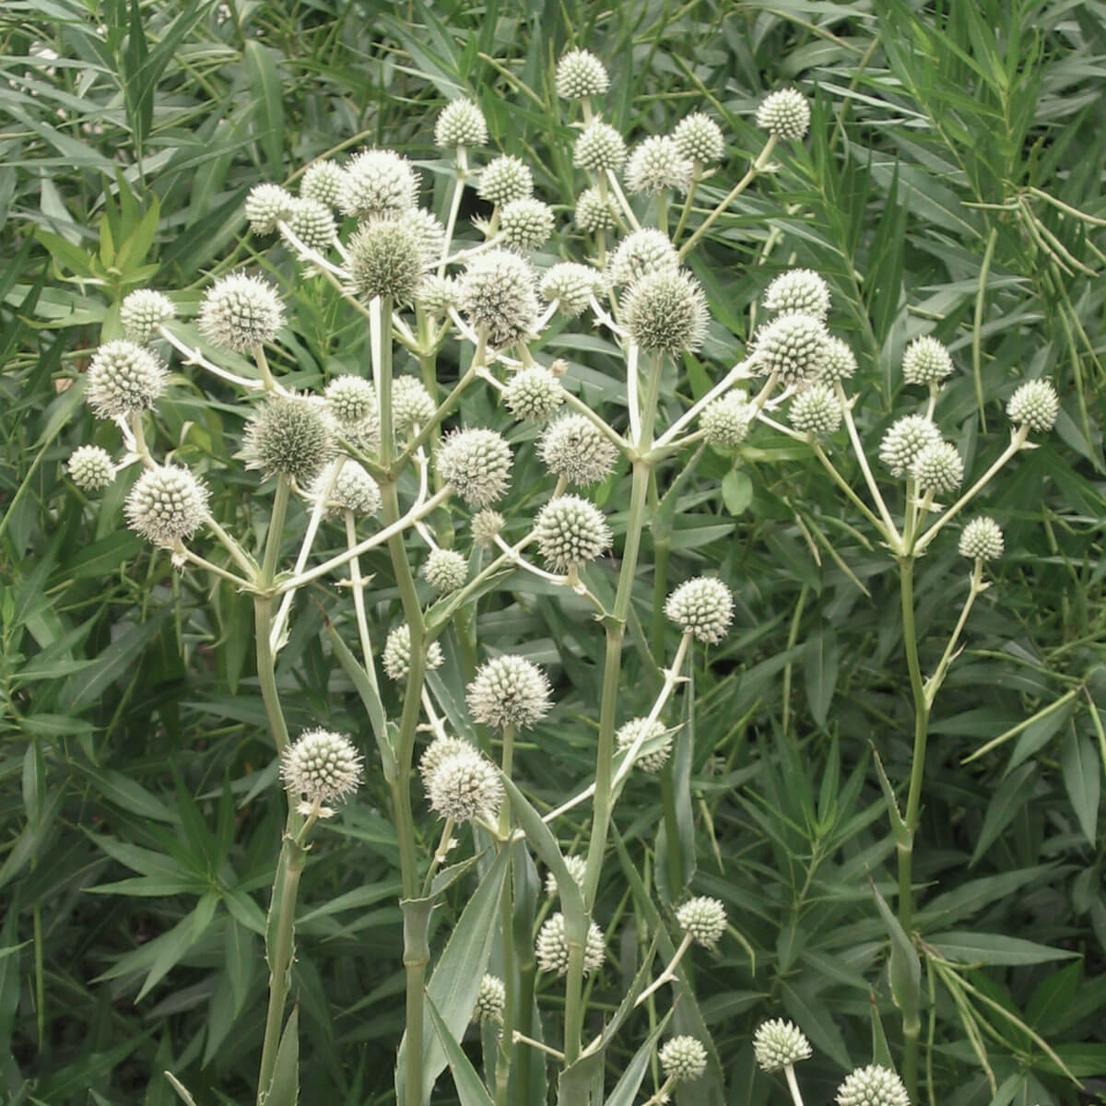
Rattlesnake Master . Eryngium yuccifolium

*Full Sun *2ft-4ft tall
*Deer/rabbit resistant
*Drought tolerant *Great pollinator for a wide variety of insects!

